COMP Cams® Now Offering Driven Racing Oil Products

Memphis, TN – Thanks to a new distribution partnership with Driven Racing Oil, COMP Cams® is making it easy for customers to get competition-proven lubrication products specifically designed for their application.
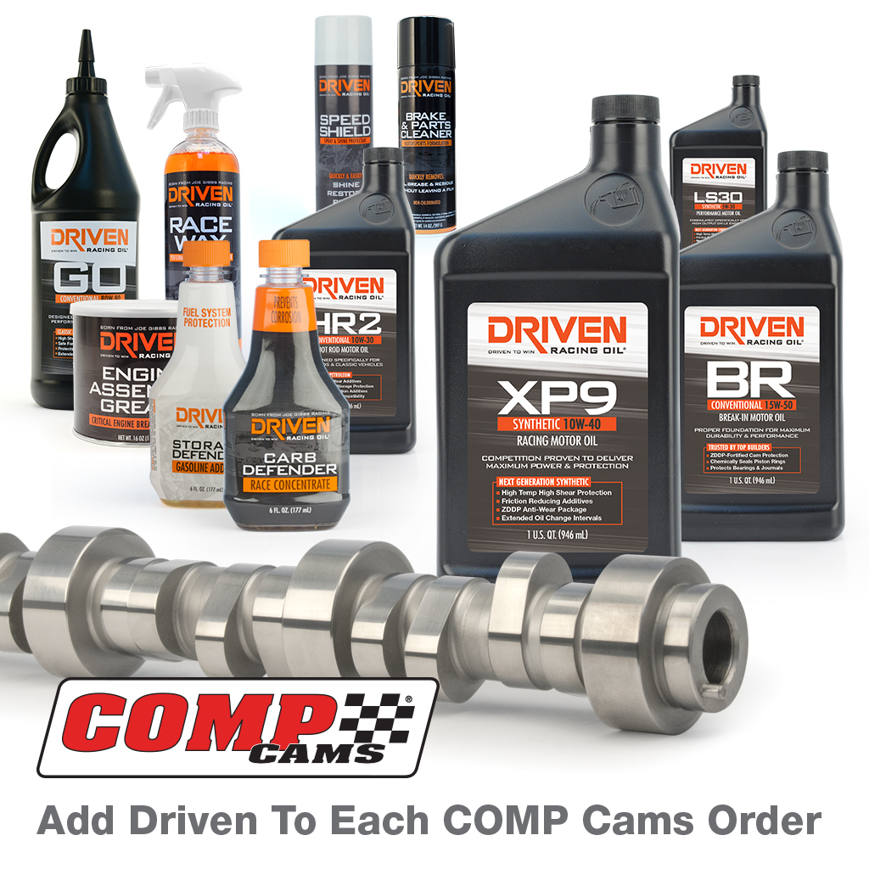
Beginning Sept. 5, COMP Cams® will become a distributor of Driven Racing Oil’s complete lineup of oil, fuel additives, transmission and specialty fluids, greases and cleaners. Technical and sales staff have been trained to recommend products offering the protection needed for each customer vehicle, given its intended use.

“COMP customers will be the winners with this new program,” said Dean Harvey, Director of Internal Sales for COMP Cams®. “The Driven product line will complement the existing COMP brand of assembly lubes and oils, and offer our customers more choices across a broad range of applications to purchase lubricants and car care chemicals that best suit their needs.”

About COMP Cams®

Founded in 1976 and based in Memphis, TN, COMP Cams® has become the automotive performance aftermarket’s “Absolute Leader in Valve Train Technology.” Our mission is to produce the highest-performing products possible, provide superior customer service and lead the industry in technological development. Additional information about COMP Cams® and its products can be found at www.compcams.com or by calling 1.800.999.0853. You can also visit us on Facebook (facebook.com/COMPWins), Twitter (twitter.com/COMPCams), Instagram (instagram.com/compcamsofficial) and YouTube (CPGNationTV.com).

Media Contact: Cindy Bullion, cbullion@compcams.com, 901.795.2400 ext. 1643.

